LAST WEEK
Sunday School Attendance 45 General $3,810.00
Worship Attendance 59 Student Aid Fund 50.00
Brotherhood Fund 100.00

Your generosity empowers our collective work for
God’s kingdom purposes. Thanks!
OUR THANKS TO

PASTORAL CARE THIS WEEK: Carl Newcomer (465-3366)

GREETERS:
Today: Joe & Janet Wilkins Next Week: Jerry & Barb Landes

MEDIA OPERATOR:
Today: unfilled Next week: unfilled

SOUND OPERATOR:
Today: Brody Robinaugh Next week: unfilled

Bethel Mennonite Church 465-4587
P.O. Box 549, 416 Washington Street www.bethelchurchwl.org
West Liberty, OH 43357 www.wbtl.tv

Transitional Pastor Consultant: Duane Beck (duaneebeck@gmail.com)
Office hours: by appointment Cell Phone: 919-741-4587
Interim Pastors: Cheryl Shank (youthpastor@bethelchurchwl.org)
Office hours: M-F 1:30 – 3:30 p.m. by appointment
Chuck Swartz (chuckandjeanie@gmail.com)
Office hours: M-W, F 9:00 – 11:00 a.m. Th 10 – Noon by appointment
Administrative Assistant: Tesa Jordan (secretary@bethelchurchwl.org)
Office Hours: Varied, by appointment Cell Phone: 419-302-8848
Elders: Steve Lapp, Barb Landes, Kathy Lehman, KJ Schrock, and Larry Evans
Pastoral Care Team: Barb Landes, Barb Kauffman, Dick Lindemer,
Carl Newcomer, Mark Thomas, Chuck Swartz

THIS WEEK

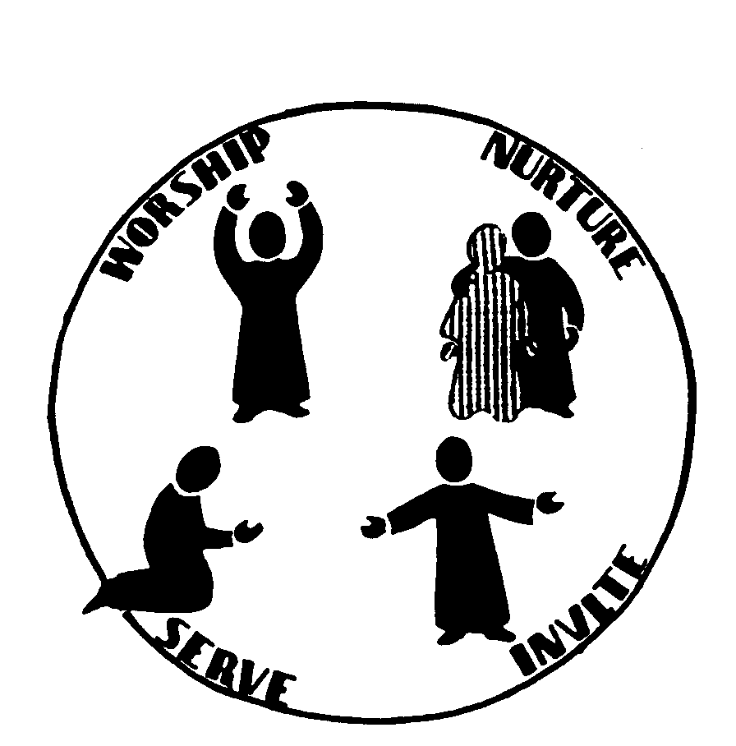

“Jesus compels us to experience and extend the
gracious rule of God by the power of the Holy Spirit.”

Vol. 59 February 12, 2017 No. 7

Preparing
By praying together Infant Nursery @ 9:15a.m.

Gathering Led by Worship Leaders, Michelle Link
Announcements
Prelude Pat Yoder
Welcome & Call to Worship Psalm 138 (excerpts)
Prayer Song Thank you for giving me the morning

Praising
Congregational Singing Byron Kauffman
With our offerings & Offertory MCC Video

Confession of Faith #131 Sing the Journey
Praising
Congregational Singing Byron Kauffman

Proclaiming
Scripture II Corinthians 5:14-21
Message “In Christ, we are a new Creation” Duane Beck
Song of Response

Sharing, Led by Pastoral Care Team, Chuck Swartz
Of our joys, requests, thanksgivings & responses
Pastoral Prayer

Sending
Sending hymn Byron Kauffman
Benediction

THIS WEEK

TODAY
9:30 a.m. —Sunday School
10:40 a.m. — Worship with Duane Beck
5:00 p.m.—Congregational Meeting

TUESDAY
9:00 a.m.—Women Serving in Love
3:00 p.m.—Bethel Homework Help

THURSDAY
7:00 p.m.—ELT meeting

NEXT SUNDAY
9:30 a.m. —Sunday School
10:40 a.m. — Worship with Duane Beck
12:00 p.m.—Noon Potluck & Congregational Meeting

ANNOUNCEMENTS
Women Serving in Love meets Feb. 14th. The meal is sack lunches with valentine Desserts. Hostesses are Jan S., Elaine N. and Lydia. Devotions by Barb E. are on “Walking in the Wilderness” and the project is bar soap or new hand or bath towels.

The transitional prayer team is suggesting that the Bethel family makes personal Paul’s prayer from Ephesians 3:16-20. Pray that God may strengthen us with power through His spirit in our innermost being so that Christ may dwell in our hearts through faith. Pray that we being rooted and established in love, may have power, together with all the saints to grasp how wide and long and high and deep is the love of Christ, and to know this love that surpasses knowledge--that we may be filled to the measure of all the fullness of God. May we give God the glory as He is able to do immeasurably more than all we ask or imagine according to His power that is at work within us. NIV

Administrative Assistant Search – With the resignation of our Administrative Assistant, we are beginning the process of looking for someone to fill this position beginning sometime in late February. If you have interest in exploring this possibility, please contact Dave Link as soon as possible.

From Peace & Justice Group: Considering these uncertain times and the increased polarization in our country, the Peace and Justice Group invites you personalize Paul’s exhortation in Ephesians 6:10-18. Find strength in the Lord, in His mighty power. Put on all the armor God provides, so you can stand up to whatever evil throws your way. Be prepared. Fasten on the belt of truth; the garment of integrity; the gospel of peace, firmly on your feet; the great shield of faith; the helmet of salvation in your hand; and the sword of the Spirit which is the word of God. Prayer is essential. Pray in the power of the Spirit and pray for all God’s people.

Budget basics and beyond: Monday, Feb. 20 – 2 or 8 p.m. In this webinar, designed for pastors, church leaders and others interested in church budgets, we’ll discuss what congregations can do to get people excited about giving, what a church budget should do and the four basic church budget models. Presented by Beryl M. Jantzi, Stewardship Education Director. See the Everence website for details.
Welcoming Immigrant and Refugees as Neighbors. Mennonite Central Committee (MCC) U.S. decries the executive actions on immigration enforcement taken this week by President Trump as well as actions on refugee resettlement expected later. In our society, rejection of the immigrant—“the other”—still runs deep. By building walls and turning away refugees we ignore Christ’s call to care for those in need and to love the newcomer. We encourage you to consider new ways you can welcome immigrants and refugees as neighbors in your community, and to make your voice heard by contacting the White House and your members of Congress. Pray with us for hearts of love toward one another.
Thank you for all your prayers, cards, visits, phone calls, flowers, food, gas cards and other gifts of support you have so generously given me during the last weeks of Julia’s journey and since her passing. You are a wonderful church family. –Pat Yoder
PRAYER & PRAISE NOTES
- Pray for Sara Ellen Stoltzfus, as she recovers from a hospital stay.
- Pray for Harry Graber, recovering from shoulder surgery.
- Alfonsina and José Luis Oyanguren, serving through Mennonite Mission Network, praise God for the first year of ministry through a radio station that transmits news, music, and educational and biblical programs to Toba/Qom communities in the Argentine Chaco. Pray that lives will be transformed through this ministry.
- Pray for Drew G.I. Hart as he delivers Staley Lectures at Bethel College, and for receptive ears to hear his message of inclusion, transformation and dismantling racism.

Partnering with Mennonite Central Committee

Mennonite Central committee (MCC) is asking that we partner with them to help scores of people rebuild their lives. Over the next 4 Sundays, thru March 5th, monetary donations can be designated for the following needs:
$30.00 will supply food for a family for 1 month
$60.00 will provide basic supplies for families in need
$200.00 will pay for shelter materials

Other MCC projects:
~ Building small businesses to teach new skills and increase income
~ Building wells, dams, and irrigation systems to bring clean water to communities
~ Working for peace in communities torn by war and conflict
~ Distributing school supplies, training teachers, and tutoring students
~ Encouraging the donations of the various kits and/or comforters
~ Support for food programs
~ Monetary donations in any amount…for “as needed”

Contributions may be made through the Bethel church offering (designate MCC on the memo line or envelope).

Pledge to Walk Together

[Please give this thought and prayer in preparation of signing this pledge next Sunday, 2/19.]

We have chosen a way forward, as a church body. Any adventure has risks, produces excitement and anxiety. None of us know exactly where the path will take us, but we are not alone. Jesus Christ is the head of this church, and as his followers we seek to RePresent Jesus each day.

The steps along this path are to: 1) Deepen our Relationship with Jesus; 2) Be a Caring Community; and 3) Engage in local mission.

The way forward depends on each of us working together for the common good. We have each been given gifts to do the work of Christ’s ministry and build up the body of Christ.

With God’s help and the Holy Spirit’s presence, I will do what I can to 1) Deepen my Relationship with Jesus; 2) Be a Caring Community; and 3) Engage in God’s local Mission. I will join with others in this body of Christ to more fully RePresent Jesus.

Name ____________________________

Date ____________________________

